External encoder
An external device to record the angle of the rotary stage Steinmeyer DT240-TM and send it to the microcontroller. That signal will be sent to the ADC acquisition board. The system works by friction between the metal breadboard and the rubber ring attached with the encoder wheel. The incremental encoder selected for this application has a resolution of 600 pulses per revolution. The relationship between the two diameters is approximately 12, for this reason the system resolution is approximately 0.05 degrees\pulse.
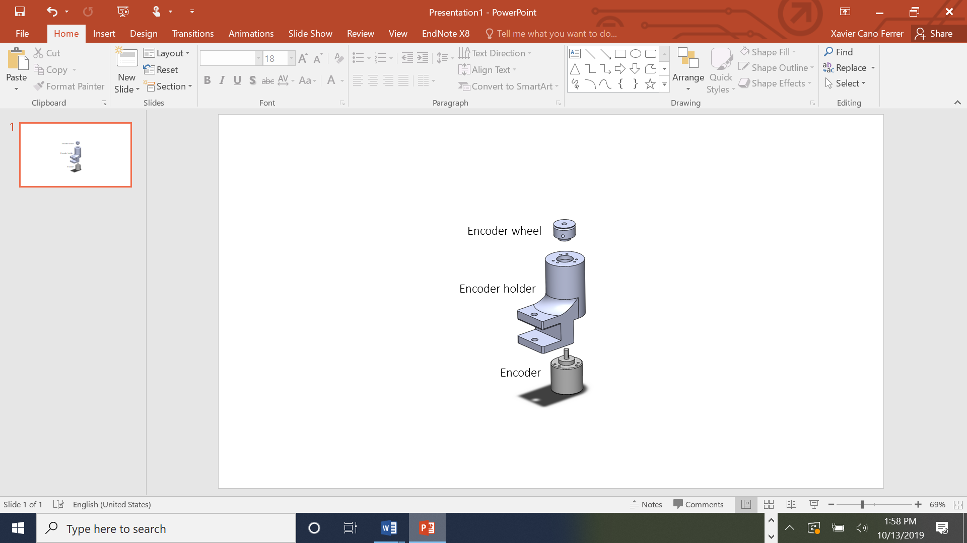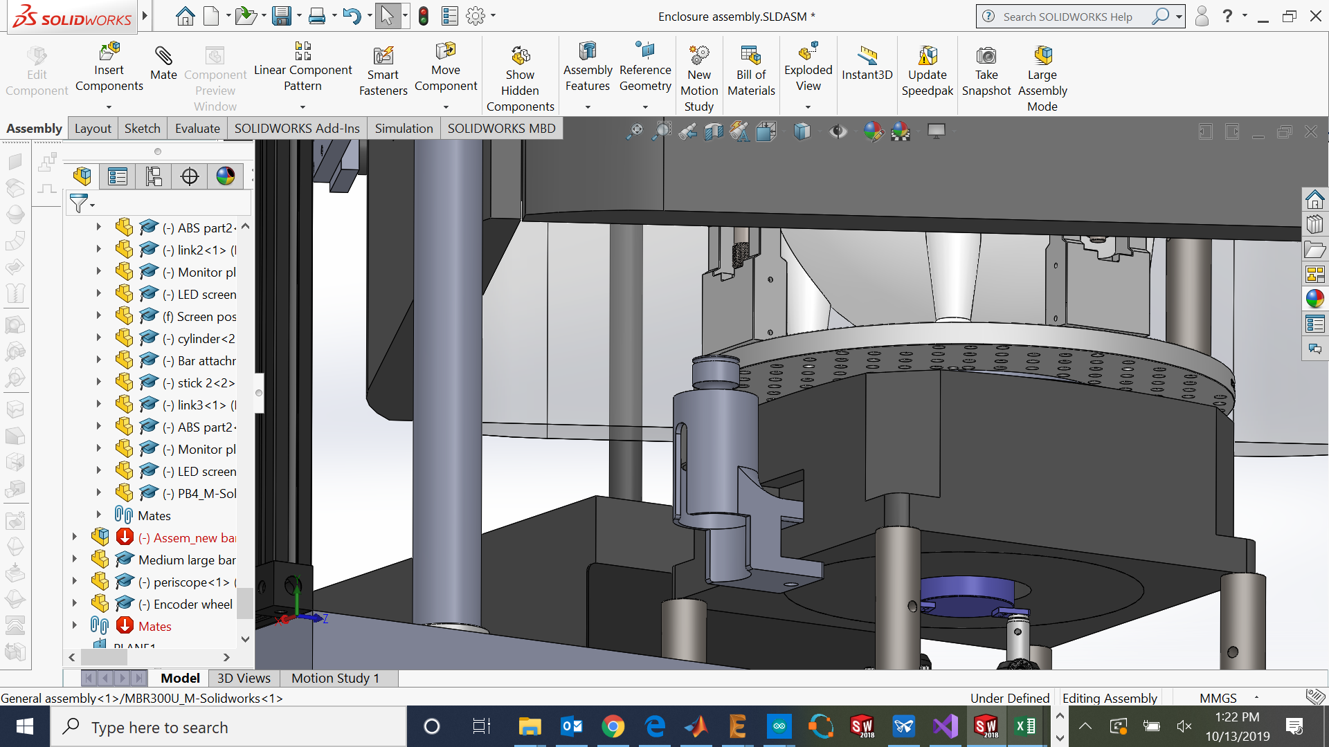
Figure 1: External encoder main components exploded view (left) on the virtual assembly (right).
Table 1: Bill of materials
Component | Quantity | Supplier | Reference
Encoder holder | 1 | - | Encoder holder.STL
Encoder wheel | 1 | - | Encoder wheel.STL
Nitrile rubber ring | 1 | - | 18.72 mm internal diameter / 2.6 mm ring diameter
Incremental encoder Wisamic 600 Pulses/rev 5-24 V DC | 1 | Amazon | https://www.amazon.co.uk/gp/product/B015GYY7XU/ref=ppx_yo_dt_b_asin_title_o00_s01?ie=UTF8&psc=1
M8 screw x 30 mm | 1 | RS Components | RS 187-1500
M3 screws x 8 mm | 6 | RS Components | RS 797-6193
M4 screw | 1 | RS Components | RS 529-949

Assembly instructions
Insert the M3 screws on the six holes to attach the encoder with the encoder holder.
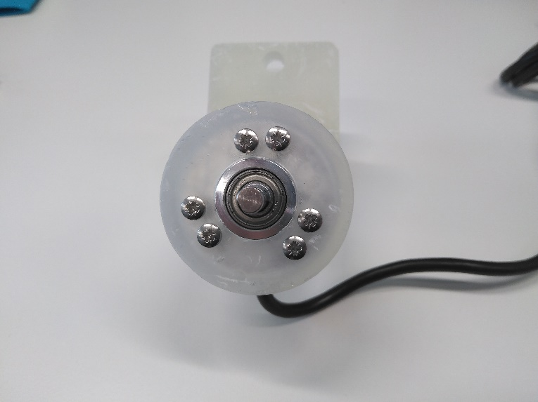
Figure 2: Encoder and holder assembled.
Insert the M4 screw on the encoder wheel with a 2 mm Allen key.
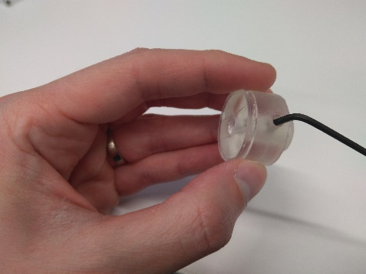
Figure 3: M4 screw inserting
Attach the rubber ring on the encoder wheel.
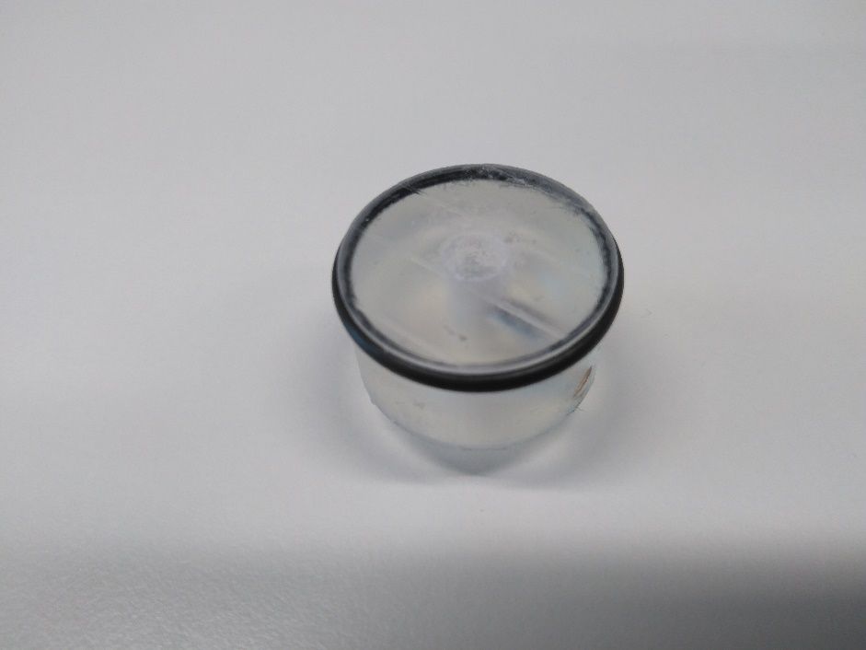
Figure 4: Rubber ring.
Use the M4 screw to hold the wheel with the encoder shaft.
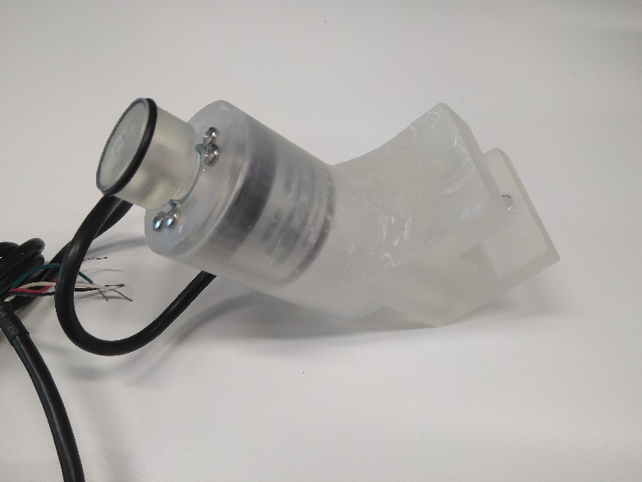
Figure 5: encoder wheel assembled with the encoder shaft.
Attach the encoder holder to the rotary stage with the M8 screw.
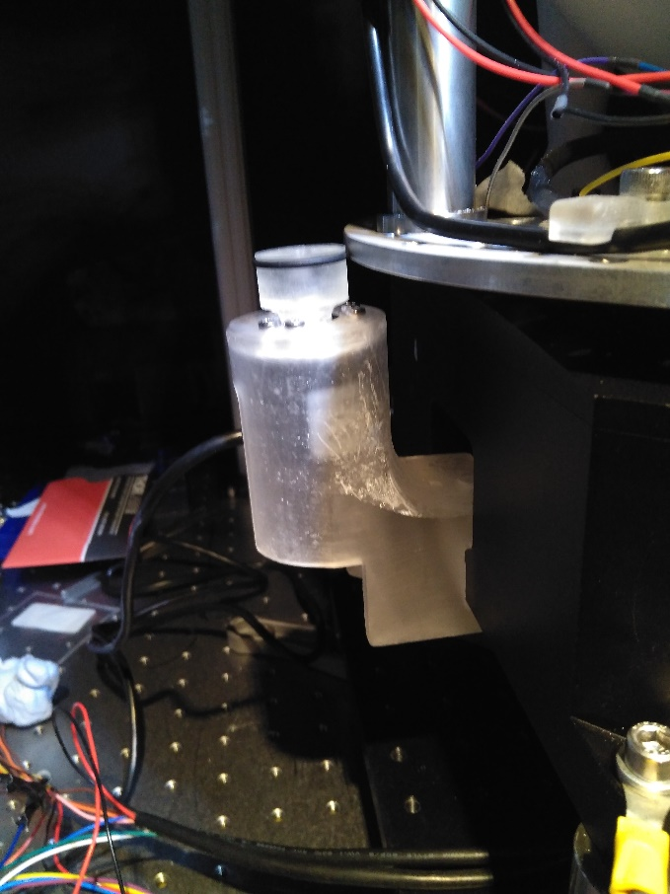
Figure 6: External encoder assembly.

